Young patient where one ear has disease that eroded a lot of the bone and other ear is healthy

Deep sinus tympani

Axial view

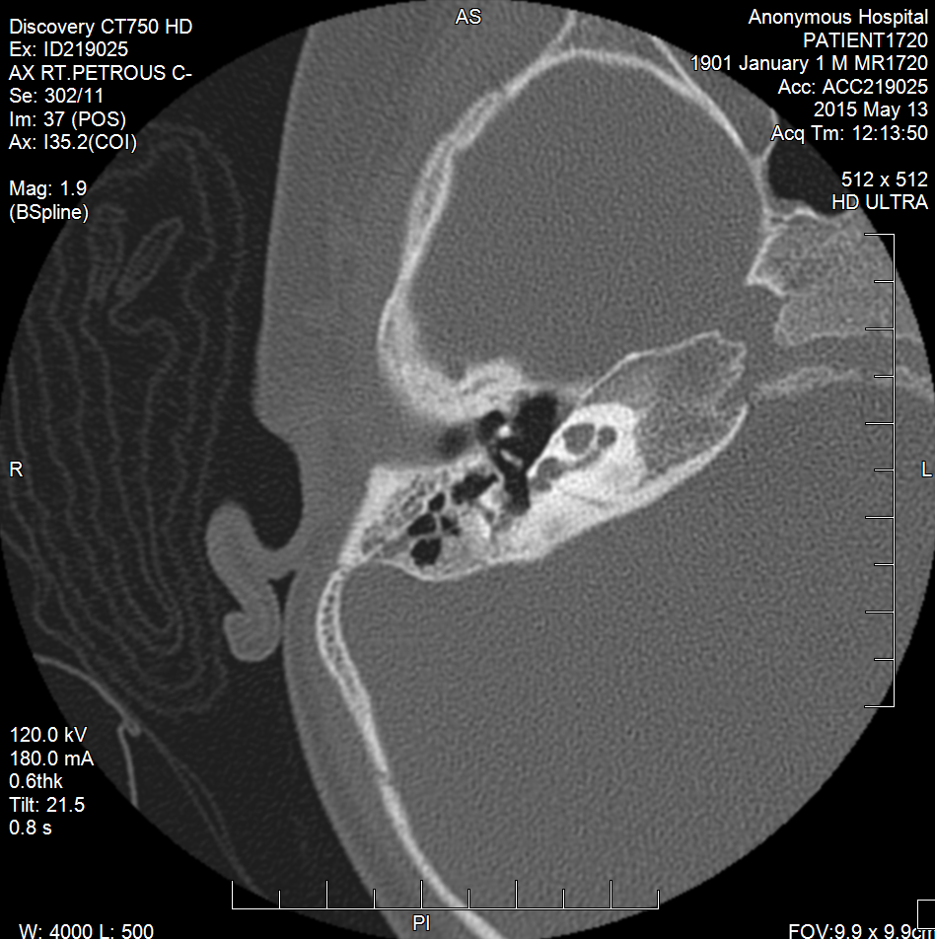

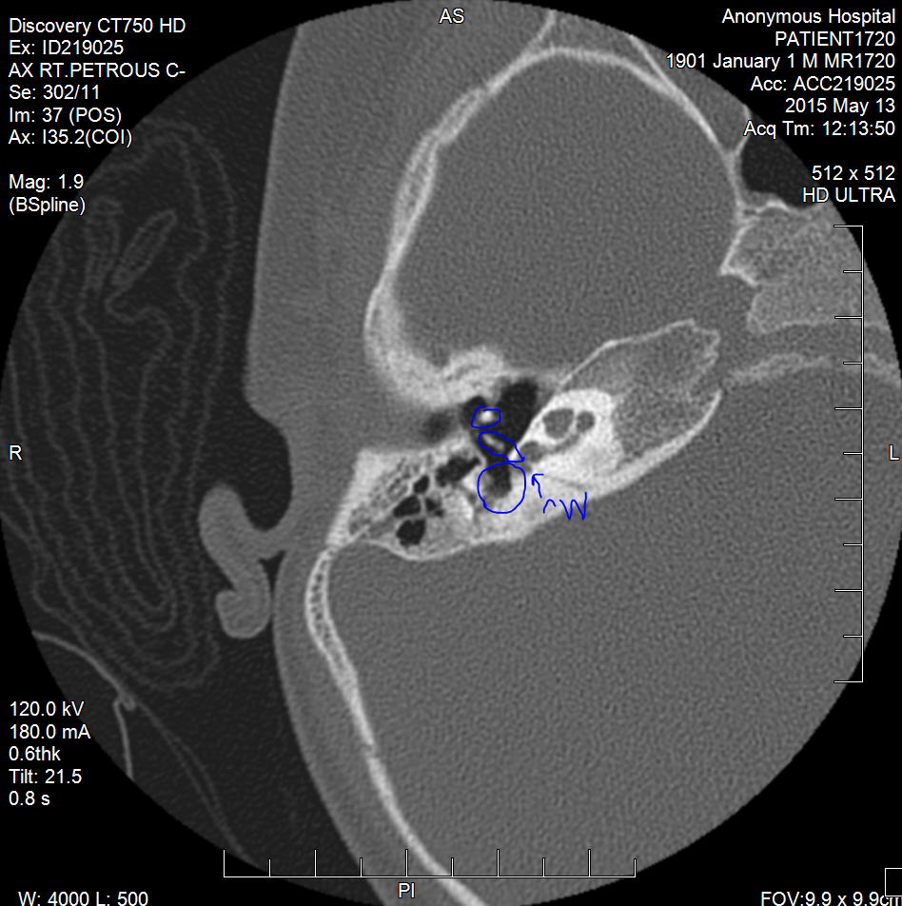

3

2

1

1 & 2 – ossicular chain

1 – malleus

2 – incus

3 – sinus tympani

Arrow points to the round window

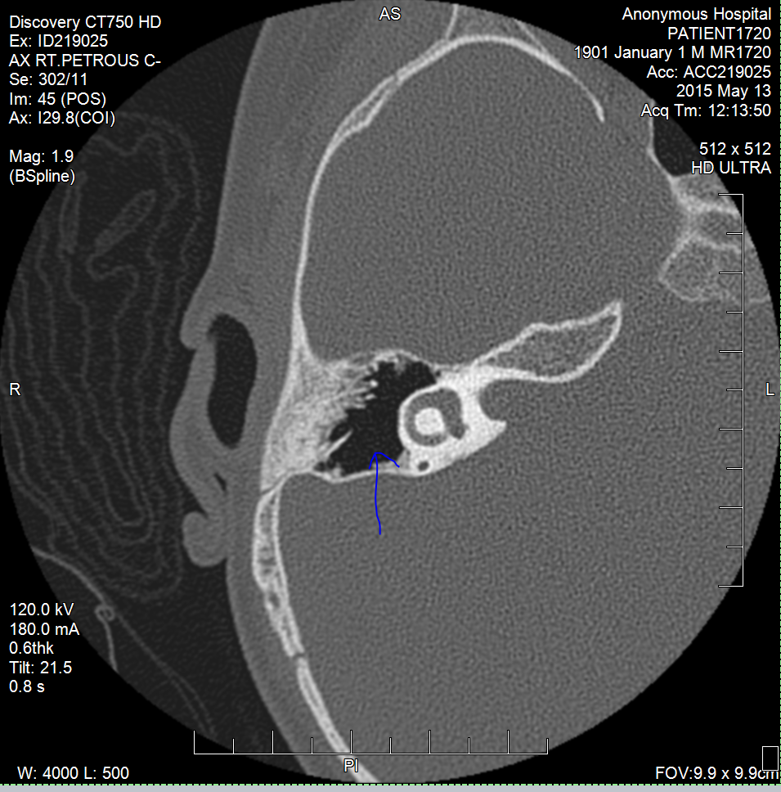

Antrum

Saggital view

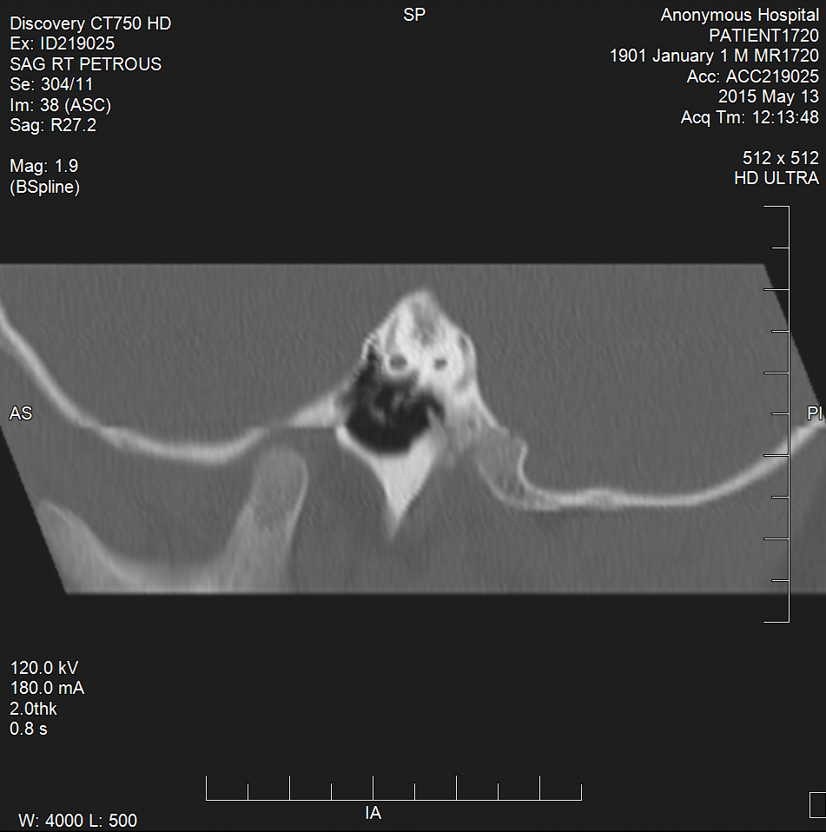

Space above ossicular chain

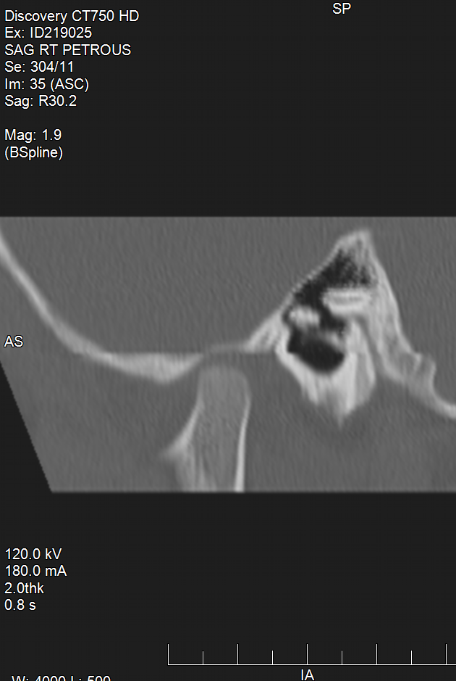 Space superior to ossicular chain (above)

ossicles

Tegman tympani – roof of ear space

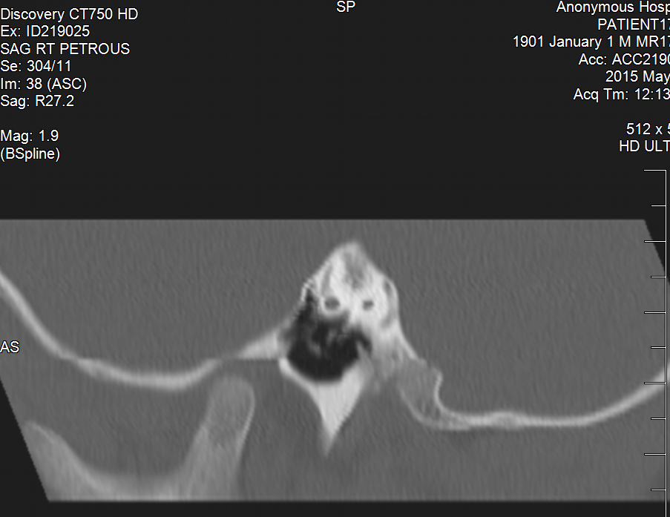

Sinus tympani

<https://users.fmrib.ox.ac.uk/~stuart/thesis/chapter_3/chapter3.html>

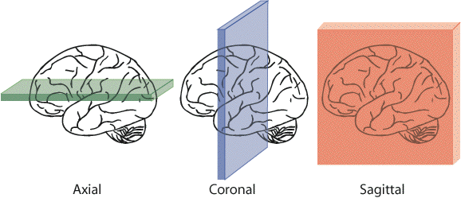

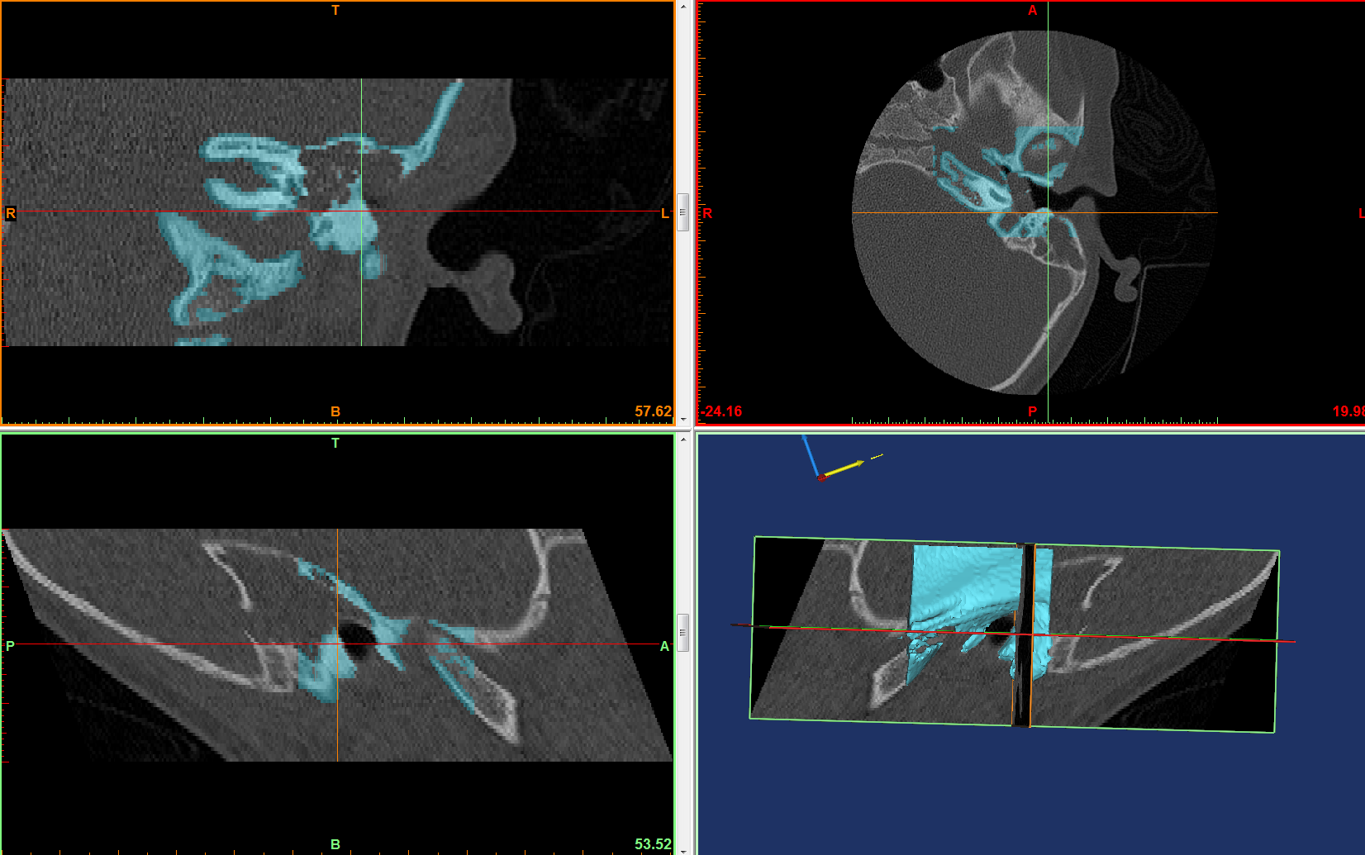

Sagittal

Coronal

Axial

Note: use the 3D model to help navigate the planes to understand what each section is showing – that will help find and then outline the sinus tympani, antrum, etc.

Axial section can be used to find and outline the sinus tympani and round window niche – use mimics to do that

Axial section: reference: <http://emedicine.medscape.com/article/875593-overview#a4>

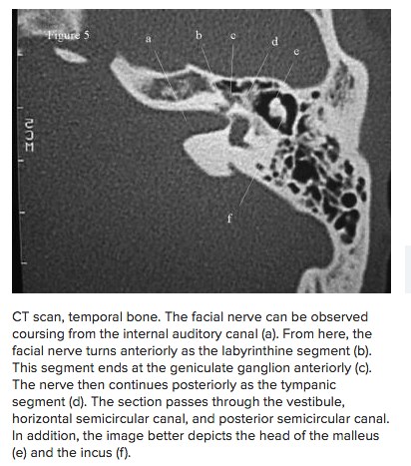

ossicles

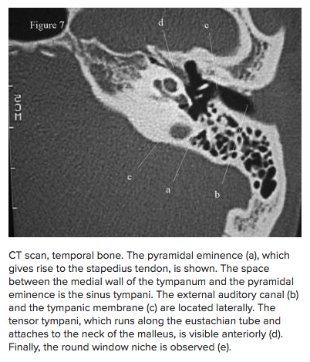

Round window niche, sinus tympani

coronal view:

find the circled area in the coronal view and outline with a different mask – space superior to malleus needs to be accessed by instrument.

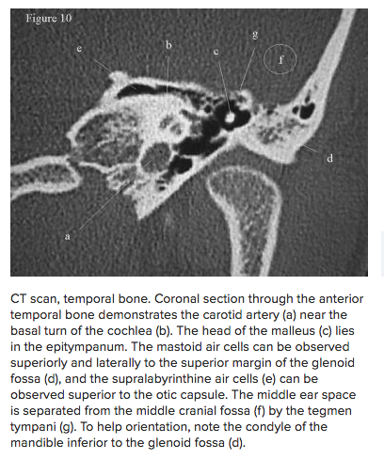

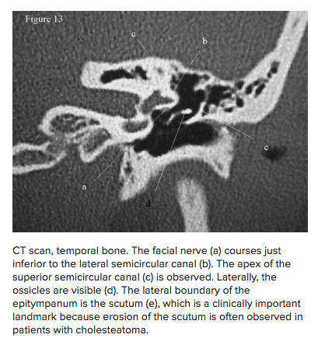

Spot superior to ossicles